Should Your Town be Capital?

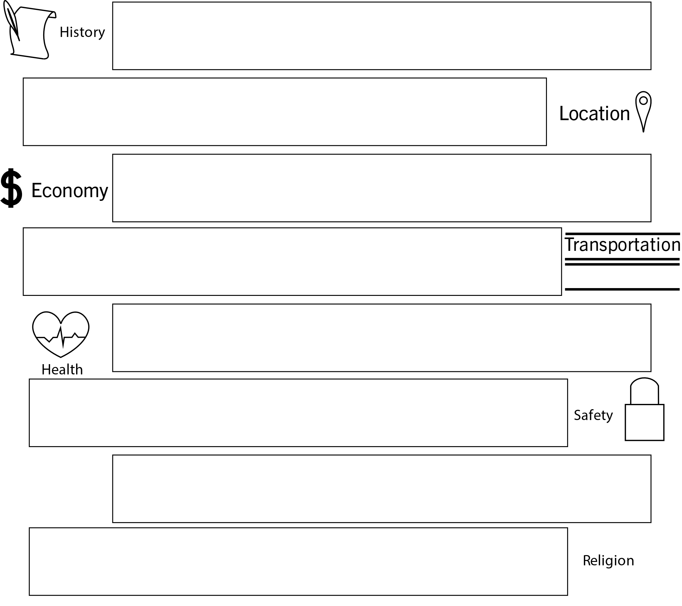
Do you think your hometown deserves to be state capital? In the boxes below, list a few of the things in your town related to history, location, economy, transportation, health, safety, population, or religion.

Design Your Capital!
Design the state capital city of your dreams! There is only one catch: it can only have three of the eight characteristics we discussed today. Choose your three characteristics and write a one-page essay explaining your choices.

American Boosterism
Option A: Conduct historical research on the period of American Boosterism. How did the culture of boosterism play into the selection of Atlanta as a capital?

Option B: Critique Henry Grady’s speech to the New England Club. What should he have included? Did he omit any information (positive or negative) that might have made a difference?

Option C: Argue for or against Atlanta remaining the state’s capital city.

