SYMBOLS OF CHANGE
Think about some of the symbols used by the people we discussed today. Take a moment and draw your own symbols for your lunch movement. Feel free to use color!



PICK YOUR SLOGAN
Choose a slogan or tactic from one of the protest movements today that you thought was very effective. Explain what made it work so well. Choose a slogan for your lunch protest movement.

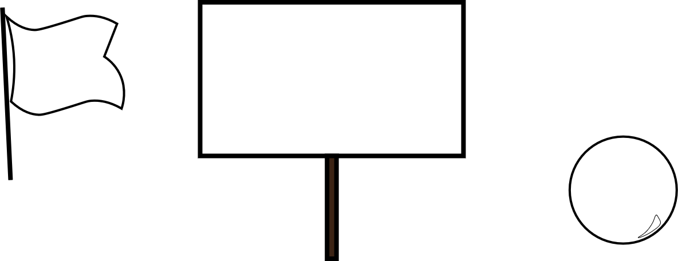

What is your slogan?

What makes your slogan effective?

What historical slogan gave you the most inspiration? Why?

Look at the School Lunch Act (79 P.L. 396, 60 Stat. 230), and find one additional piece of legislation that determines what you eat for lunch. Draft a piece of legislation that would ensure your desired changes get made. Support your argument with language found in the legislation that already exists.

Research the history of voting in the United States. Based on your research, choose one thing you would change if you could (electoral college, digital/analog voting, two party system, make it easier/more difficult to vote, extend/retract popular vote). Explain why this change should happen, and/or how to implement the change.

https://federaleducationpolicy.wordpress.com/2011/02/19/1946-national-school-lunch-act/

