Off Reserves Procedures in Alma
- Pull the reading list from the binders on the reserve shelf
- If the reading list has no physical items, skip to step 9. If the list has physical items, pull the items from the reserves shelf.
- Search for each item in Alma by scanning the barcode in the search bar at the top of the screen. Be sure that the search parameters are set to “All Titles” and “Keywords”
- On the item record, click on “Other details”
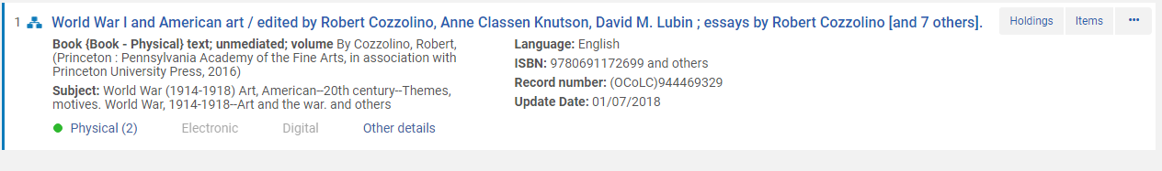
- On the “Other Details” tab, check to make sure the item is only associated with one course. 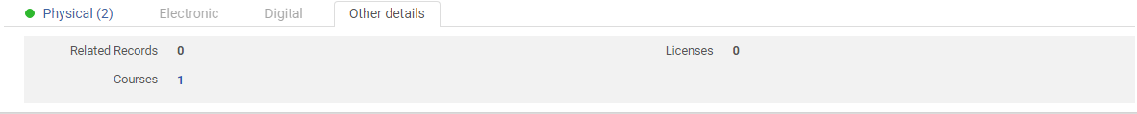
- If the number next to courses is 1, proceed to step 7. If the number is 2 or higher, click the number next to courses. This will show you a list of courses with which the item is associated. If any of the courses are listed as “Active,” return the item to the reserves shelves. If all the courses are listed as “inactive,” proceed to step 7.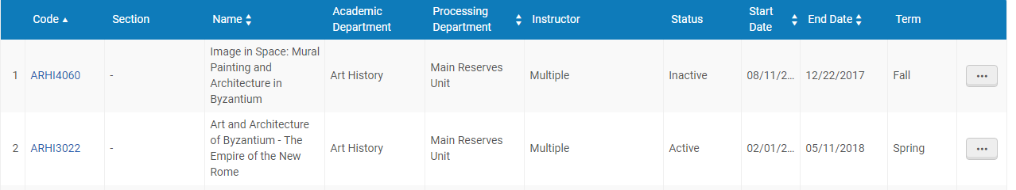
- For any items that are not associated with an active course reserves, go to “Scan In Items.” Select the “Change Item Information” tab. 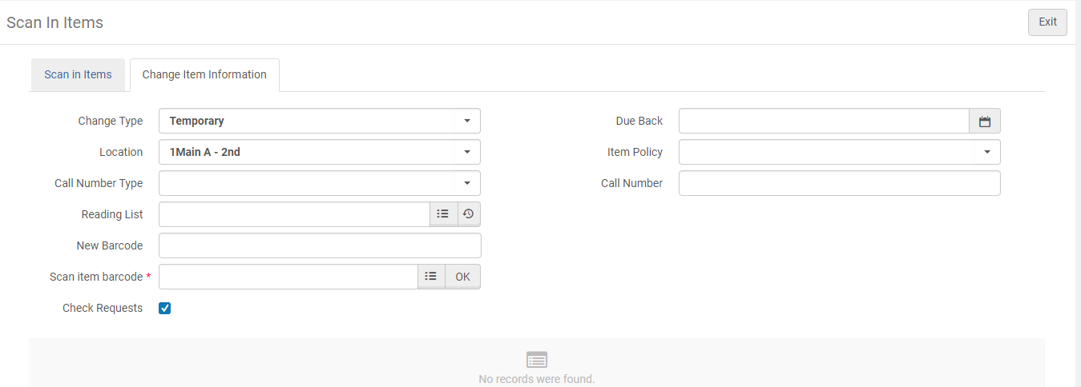
Set the change type to “Restore” 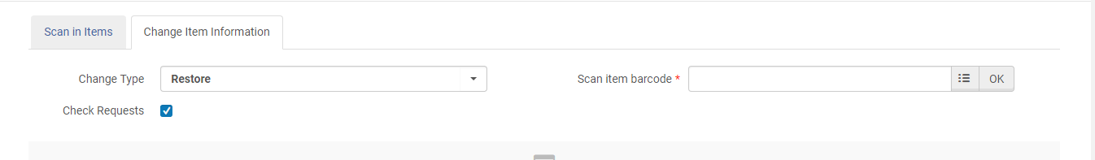Scan the item barcodes in the “Item Barcode” field.
- When all physical items for the list have been scanned, return their books bands to the boxes by the reserves shelves. Sensitize the books and place them on the “To Be Shelved” cart.
- If the list has no e-reserves, proceed to step 10. For lists with e-reserves, open the Reserves-Docs (R) Drive under “My Computer.” Locate the course in the “Main-Current” folder. Open a second “My Computer” window and go to the Reserves-Doc Drive in this window also. In your second Reserves-Docs window, open the folder for the past semester. (For instance, if you are taking down Fall 2017 reserves, open the “Main-Fall2017” folder. Drag and drop the course folder from “Main-Current” to the previous semester folder (i.e., “Main-Fall2017”).
- Go to “Courses” in Alma and search for the course code of the list. Ensure that the list is set to “Inactive.” 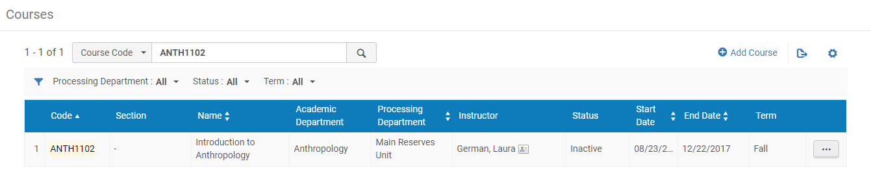
Provided the course is set to “Inactive,” click the elipse and select reading list. On the reading list page click the elipse and select “Remove Associated Course.” 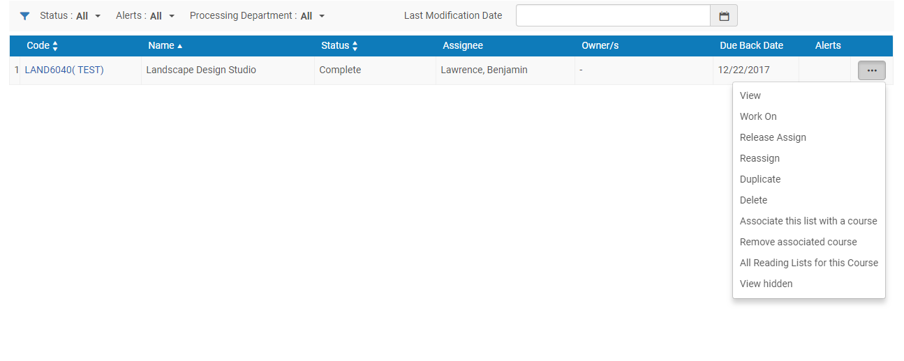
- Return to courses and pull up the list you are working on. Click the elipse and select “Delete.”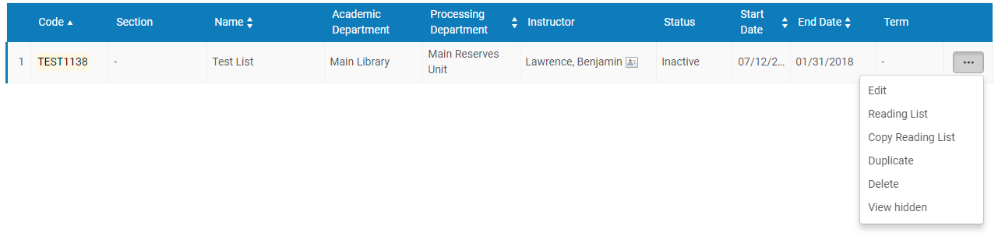A dialogue box will appear asking if you are sure you want to delete the list. Make sure you are on the course page and NOT the reading list page and then click “Confirm.” DO NOT DELETE THE READING LIST.

- Place the course reserves pick list in the “To Be Filed” basket next to the course reserves shelf.
- CONGRATULATIONS! YOU DID IT!

