Creating Course Reserves in eLC
- After processing the PDFs of the readings for the course reserve request, email the instructor and ask for written permission to be added to their course in eLC and the CRN (course reference number) for their course. Send the CRN to the reserves coordinator, and they will add you to the course in eLC.
- Go to the course in eLC. Click the content tab.
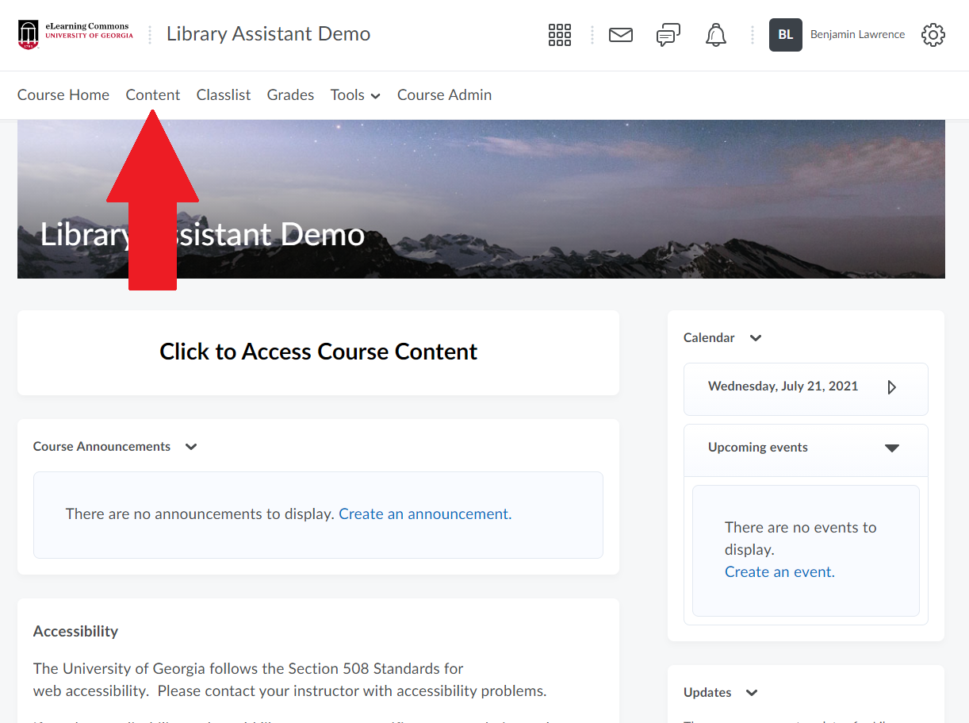
- Go to the bottom of the left side column and enter “Course Reserve Readings” in the “Add a module…” field. Press enter. This will create the course reserves module in the eLC course.
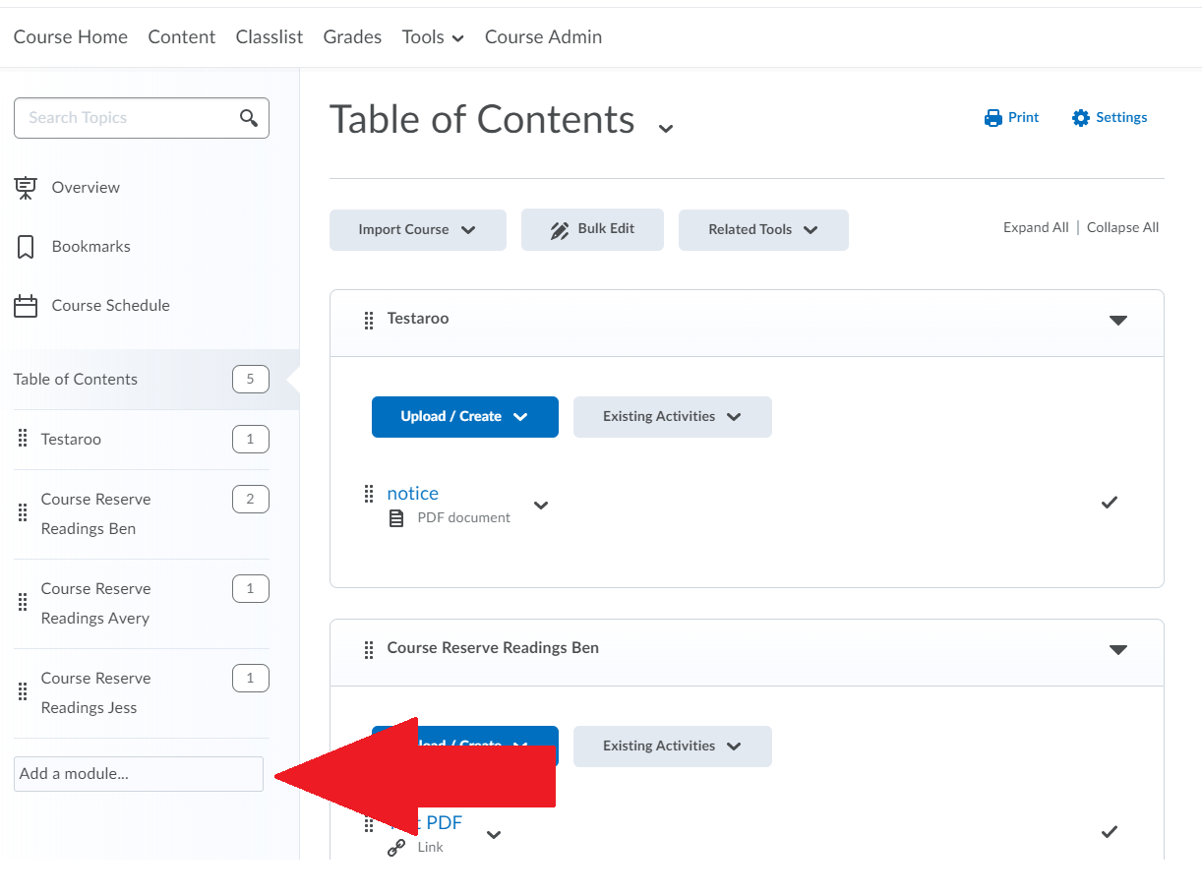
- Click Upload/Create and select “Create a Link” from the dropdown menu.
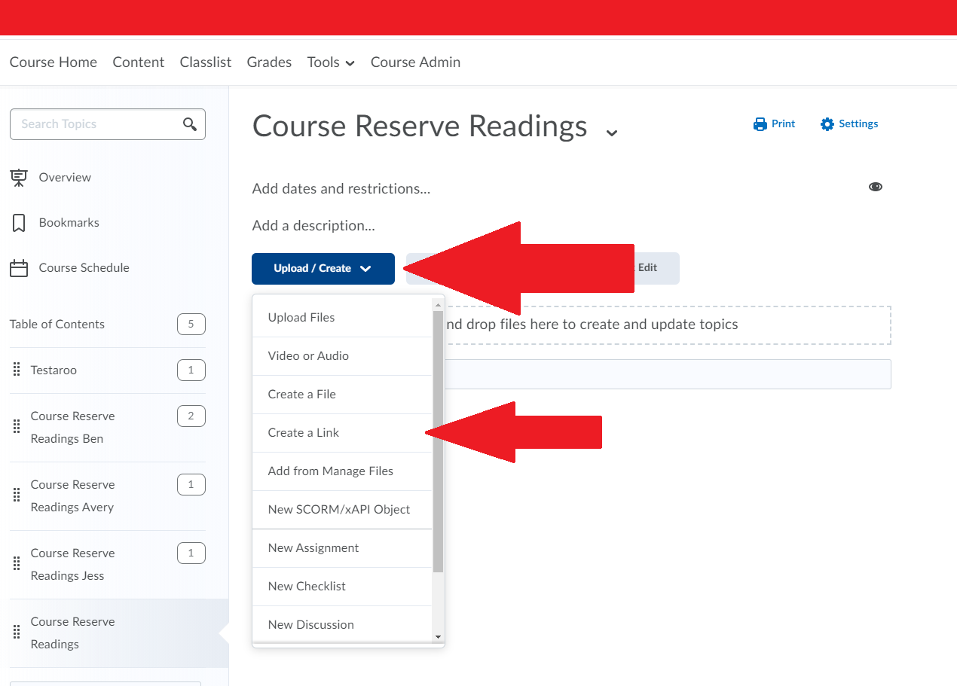
- Enter the title and author of the reading in the title field. Enter the reading’s URL (created the from http document in the R drive) in the URL field. Click create.
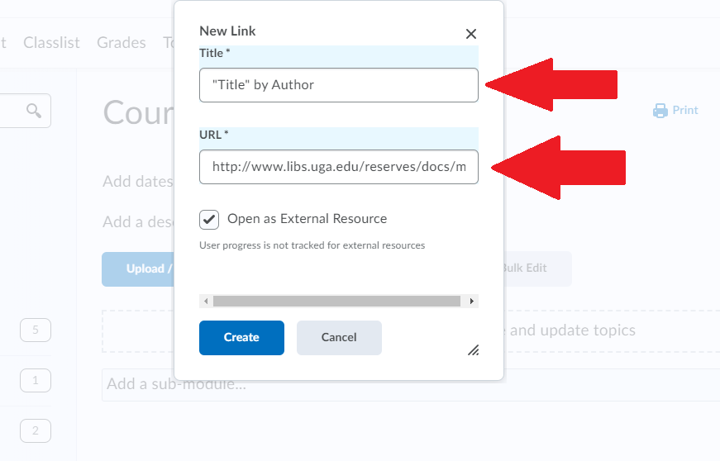
- This will open the reading’s record in eLC. To add further readings, return to the Course Reserve Readings module and repeat steps 4 and 5.

Transferring a Course Reserve Module in eLC
- Go to the course page for the course to which you are copying readings in eLC. Click “Course Admin.”
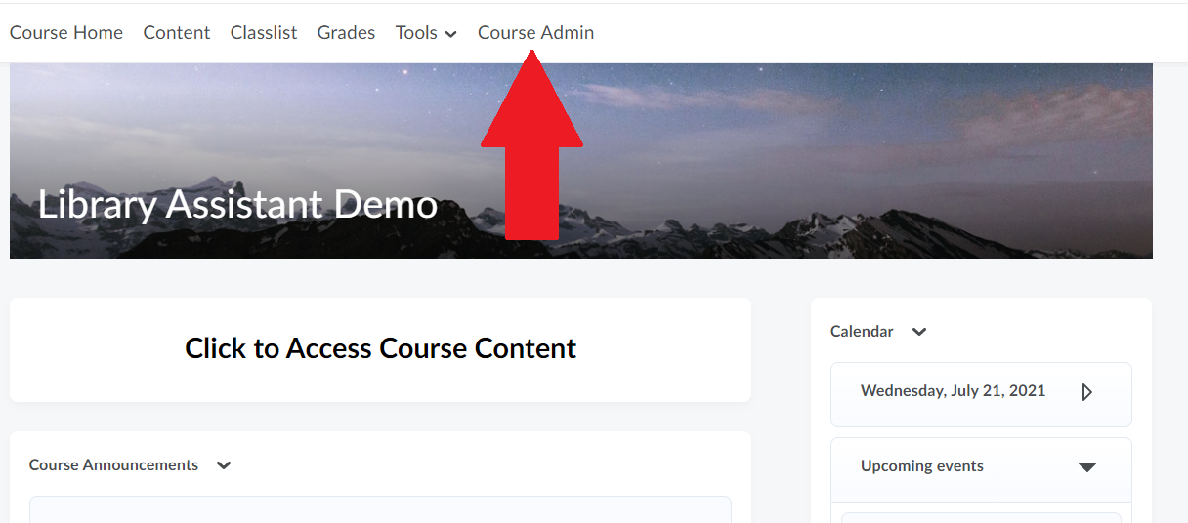
- Under Site Resources select “Import/Export/Copy Components.”
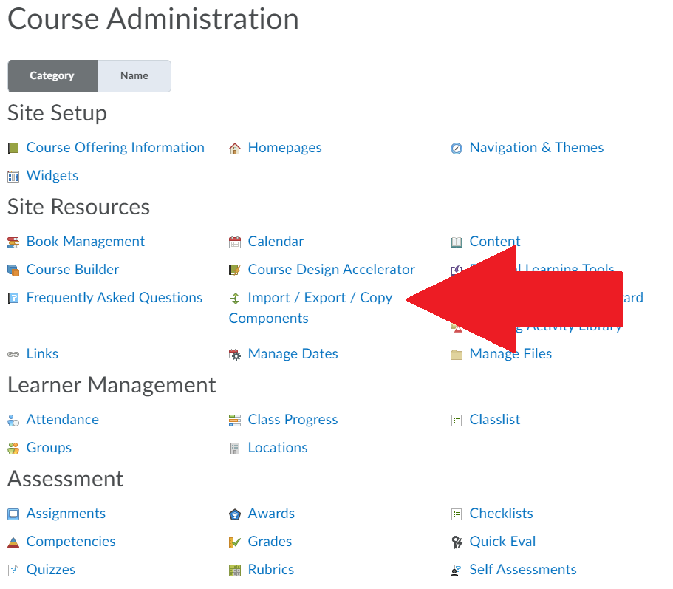
- Leave “Copy Components from another Org Unit” checked and click “Search for offering” under “Course to Copy”
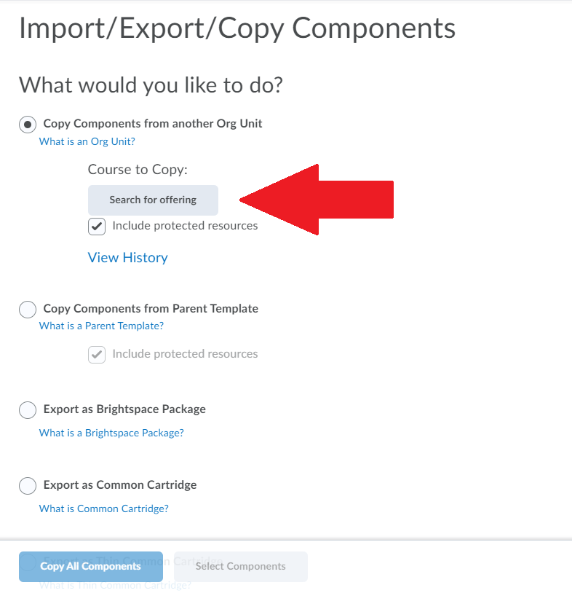
- Enter the course code for the course from which you are copying readings in the search field. Click search. Select the course from which you are copying readings. Click “Add Selected” at the bottom of the screen.
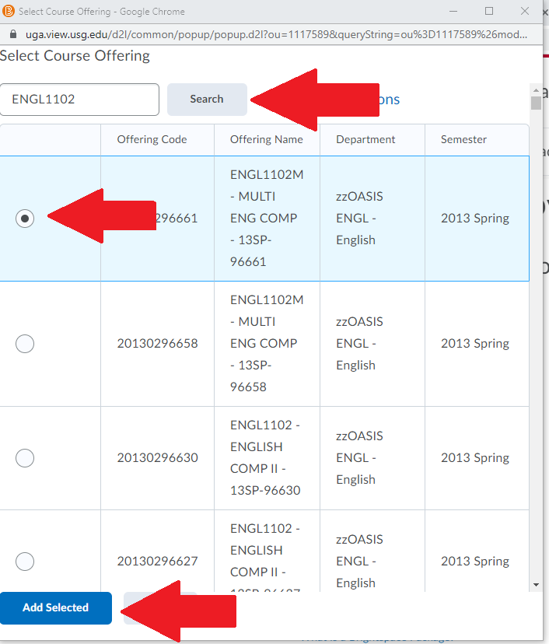
- At the bottom of the Import/Export/Copy Components page, click “Select Components.” Do NOT click copy all components.
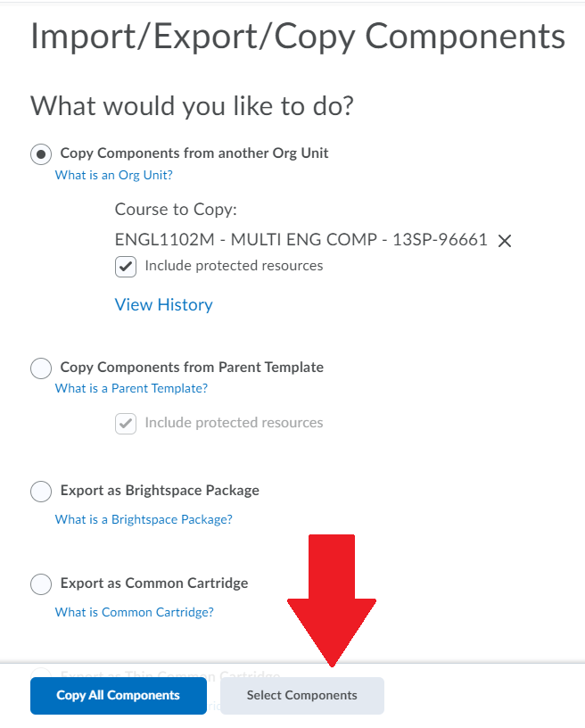
- On the “Choose Components to Copy” page, select “Content.” Then, click on “Select individual items to copy.” Once this is selected, click “Continue” at the bottom of the page.
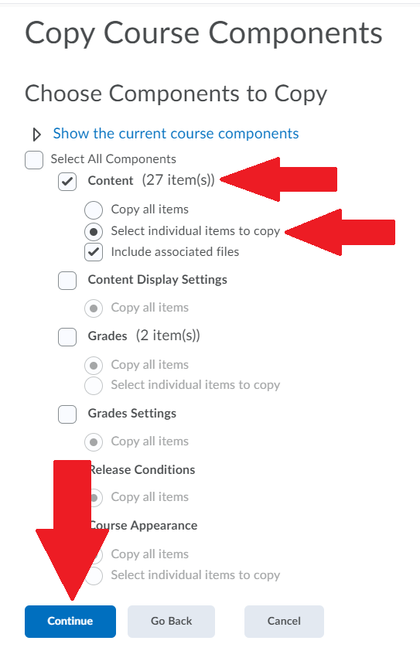
- From the list of Content Modules, select “Course Reserve Readings.” Note: there will typically be more than one Content Module listed on this page, unlike the picture below. Be sure to only select “Course Reserve Readings.” Click continue at the bottom of the page.
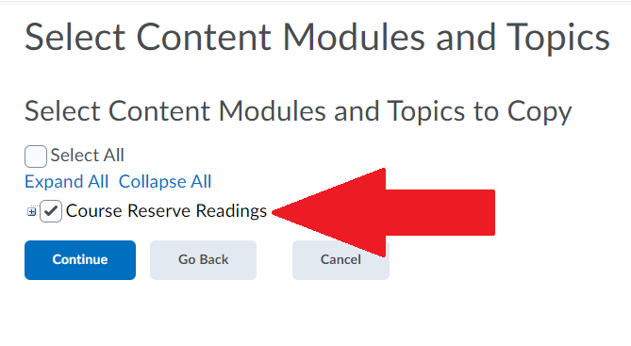
- At the bottom of the “Select Course Material” page, click “Finish.”
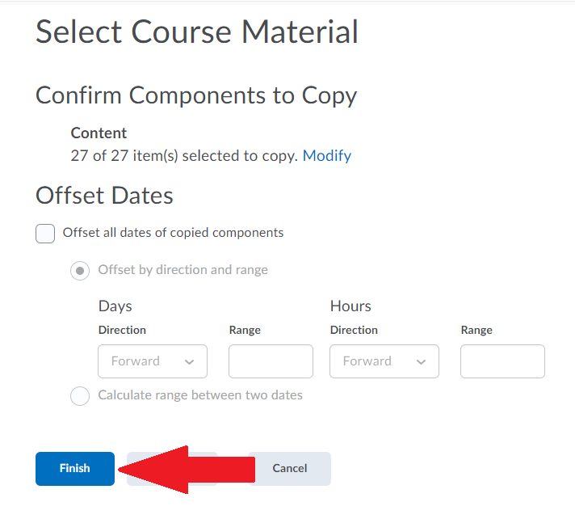
- Wait for the module to complete transferring on the next page.
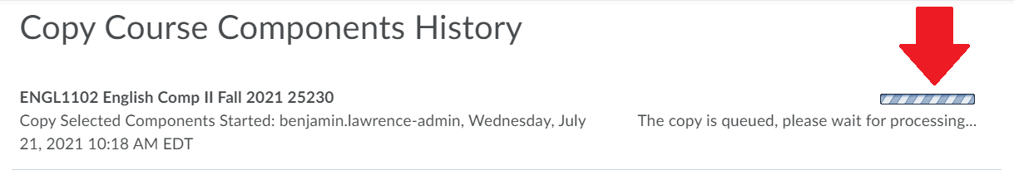
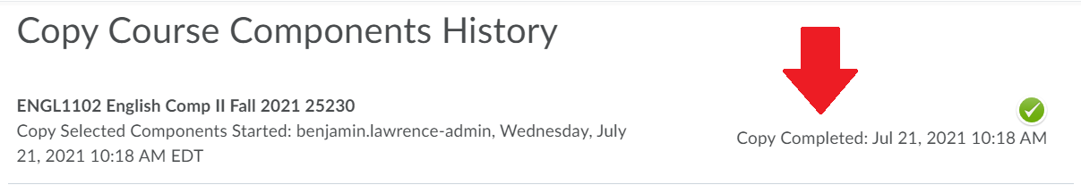
- Return to the course Content page and make sure the readings transferred correctly.

